**HOW TO MAKE VEGETABLE SALADS**

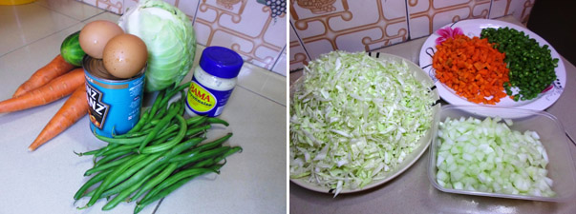

There are basically two types of salads that are popularly eaten in Nigeria, Salads happens to be one of the healthiest set of foods that I know, especially the vegetable salad, I also like the fruit salad but this is by no means in comparison with the former.

What you find below is a plate of vegie salad, it looks delicious right? You can serve it this way or serve with any one of the rice meals.

Vegetable salad

Below are the ingredients used in making Nigerian Vegetable salads, you can double or reduce it, depending on the number of people you are looking to serve.

**INGREDIENTS FOR NIGERIAN SALADS**

* Medium size cabbage
* 4 medium size carrot
* lettuce leaves
* 2 cups of chopped green beans
* half cup peas (optional)
* 3 cooked eggs
* one can of baked beans
* 2 big size of cucumber
* salad cream (heinz, BAMA mayonnaise)
* Just know that most vegetable salads are usually 50% cabbage, 30% carrot/green beans, 5-10% cucumber while the lettuce leaves, peas, eggs and cream make up the other 10%

**HOW TO MAKE VEGETABLE SALAD**

* Preparation: chop the carrot /green beans/cucumber and set aside in different bowls, I like to peel off the green back of cucumbers and also remove the center seeds, you will learn how this is done by watching how I made salad via the video below.
* Slice the cabbage too in a different tray (we use tray often in our home), slice the lettuce leaves, boil the eggs and remove the shell (2-3 eggs).
* You then need to soften the cabbage, green beans, carrot and peas, most of the times we boil carrot, green beans and peas together and soak the cabbage in hot water for a minute.
* Here is how it is done, add the carrot, green beans and peas to boiling (small) water, and allow to simmer on low heat for 3-4 minutes (this is to soften them a little, this practice is elaborated in the video below) heat water to 100 degree celcious (boiling point) and pour into the sliced cabbage in a bowl, allow for a minute then drain.
* Also drain the carrot/green beans, peas and set aside in a bowl, now you are ready for the mixing part.
* Most people choose to mix salad in a large plate/bowl or a tray.